TryHackMe | Internal

Security Assessment Findings Report

Business Confidential

Date: May 21st, 2021

Table of Contents
Table of Contents 2
Confidentiality Statement 3
Disclaimer 3
Contact Information 3
Assessment Overview 4
Assessment Components 4
External Penetration Test 4
Finding Severity Ratings 5
Scope 6
Client Allowances 6
Executive Summary 7
Attack Summary 7
Security Strengths 8
Network Segmentation 8
Security Weaknesses 8
Unrestricted Logon Attempts 8
Credentials Found in Text Files 8

Confidentiality Statement

This document is the exclusive property of Internal Company and James Colbert (also referred to in this document as “consultant”. This document contains proprietary and confidential information. Duplication, redistribution, or use, in whole or in part, in any form, requires consent of both Relevant and James Colbert.

Consultant may share this document with auditors under non-disclosure agreements to demonstrate penetration test requirement compliance.

Disclaimer

A penetration test is considered a snapshot in time. The findings and recommendations reflect the information gathered during the assessment and not any changes or modifications made outside of that period.
Time-limited engagements do not allow for a full evaluation of all security controls. Consultant prioritized the assessment to identify the weakest security controls an attacker would exploit. Consultant recommends conducting similar assessments on an annual basis by internal or third-party assessors to ensure the continued success of the controls.

Contact Information
Name | Title | Contact Information
Internal Company
John Smith | VP, Information Security (CISO) | Office: (555) 555-5555  Email: john.smith@demo.com
Jim Smith | IT Manager | Office: (555) 555-5555  Email: jim.smith@demo.com
Joe Smith | Network Engineer | Office: (555) 555-5555  Email: joe.smith@demo.com
Consultant
James Colbert | Lead Penetration Tester | Office: (555) 555-5555  Email: jamescolbertv@gmail.com

Assessment Overview

From May 20th, 2021 to May 22nd, 2021, consultant engaged in an external security assessment to evaluate the security posture of Internal Company.
Phases of penetration testing activities include the following:
- Planning – Customer goals are gathered and rules of engagement obtained.
- Discovery – Perform scanning and enumeration to identify potential vulnerabilities, weak areas, and exploits.
- Attack – Confirm potential vulnerabilities through exploitation and perform additional discovery upon new access.
- Reporting – Document all found vulnerabilities and exploits, failed attempts, and company strengths and weaknesses.

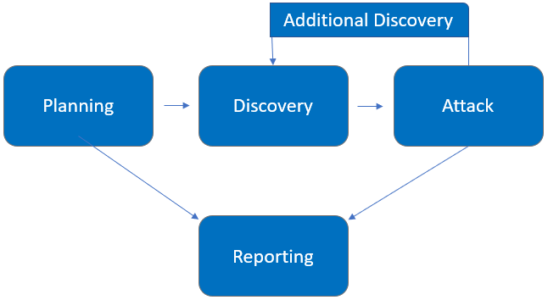

Assessment Components

External Penetration Test

An external penetration test emulates the role of an attacker attempting to gain access to an internal network without internal resources or inside knowledge. Consultant attempts to scan and enumerate the external network of Internal company in an effort to find any security flaws that could potentially exploited by a malicious actor.

Finding Severity Ratings

The following table defines levels of severity and corresponding CVSS score range that are used throughout the document to assess vulnerability and risk impact.

Severity | CVSS V3 Score Range | Definition
Critical | 9.0-10.0 | Exploitation is straightforward and usually results in system-level compromise. It is advised to form a plan of action and patch immediately.
High | 7.0-8.9 | Exploitation is more difficult but could cause elevated privileges and potentially a loss of data or downtime. It is advised to form a plan of action and patch as soon as possible.
Moderate | 4.0-6.9 | Vulnerabilities exist but are not exploitable or require extra steps such as social engineering. It is advised to form a plan of action and patch after high-priority issues have been resolved.
Low | 0.1-3.9 | Vulnerabilities are non-exploitable but would reduce an organization’s attack surface. It is advised to form a plan of action and patch during the next maintenance window.
Informational | N/A | No vulnerability exists. Additional information is provided regarding items noticed during testing, strong controls, and additional documentation.

Scope of Work

Assessment | Details
External Penetration Test | 10.10.158.123 (On TryHackMe network)

- Client has requested that James Colbert secure two flags as proof of exploitation:
  - User.txt
  - Root.txt

Client Allowances

- Any tools or techniques are permitted in this engagement
- Locate and note all vulnerabilities found
- Submit the flags discovered
- Only the IP address assigned to your machine is in scope
- Find and report ALL vulnerabilities

Executive Summary

James Colbert engaged in an external security assessment against Internal company from May 20th, 2021 to May 22nd, 2021. Using a series of reconnaissance and attack techniques, the consultant was able to successfully compromise and obtain root access on Internal’s internal network. During the course of the testing, the consultant identified several vulnerabilities in Internal company’s security posture. It is highly recommended that Internal Company address these findings as soon as possible, as the vulnerabilities are easily found through basic reconnaissance and are exploitable without much effort.

Attack Summary

The following table describes how TCMS gained internal network access, step by step:
Step | Action | Recommendation
1 | Identified Wordpress admin login page for Internal blog. | Limit Wordpress login to internal access only, or require VPN authentication for access.
2 | Successfully brute forced WP login - the username was set to default “admin”. | Update administrator username, and enable mechanism for account lockout after a certain number of failed logins to prevent brute force attacks from succeeding.
3 | Modified active theme on blog, and added malicious PHP code to facilitate remote access. | This is a difficult attack to prevent, as administrator access had already been obtained by the consultant.  A possible preventative measure for this would be to send notification for any administrative changes that are made in the WP admin portal.
4 | Elevated permissions through the discovery of user credentials in a text file. Discovered additional credentials after pivoting in another text file. | Facilitate employee training for good cyber hygiene and best practices. Storing of user credentials in a text file should never occur.
5 | Accessed internal Jenkins server and used Groovy to enable remote access. | Log all scripting commands on the Jenkins server, and have admins provide business justification for all such activity.
6 | Discovered root credentials in a text file on Jenkins server, and successfully used credentials to SSH to Internal primary server. | As noted above, text files should never hold user credentials - and they should especially not hold elevated credentials. It is recommended that the company invest in user training.

Security Strengths

Network Segmentation

During the assessment, James Colbert was not able to see the Jenkins server on the initial scan. This was a result of the network segmentation, and added an extra layer of complexity to this assessment. This could potentially discourage attackers from attempting to exploit Internal company’s network in the future.

Security Weaknesses

Unrestricted Logon Attempts

The consultant was able to easily brute force the Wordpress administrator login. This was mostly due to the admin username being the default setting (“admin”), and no brute force prevention being present on the login page. Over 500 failed attempts were made before the password was successfully brute forced.

Credentials Found in Text Files

James Colbert discovered two sets of credentials (user “aubreanna” as well as “root”) stored in text files. This is extremely poor security hygiene, and is low-hanging fruit for any potential attacker.

Vulnerabilities by Impact

The following chart illustrates the vulnerabilities found by impact:

